Doing Simple Arithmetic Operations
- R follows order of operations and will calculate much like a calculator
- > #code to do some basic arithmetic operations and their results
- > 6+13*2-6
- [1] 26
- > -3+16/4+7
- [1] 8
- > #creating a vector called “vec1” and then I will sum the values of the vector
- > vec1<-c(1,3,5,7,9)
- > sum(vec1)
- [1] 25
- > #creating a vector called “vec2” where I add 4 to each variable value and then print out value
- > vec2<-vec1+3
- > vec2
- [1] 4 6 8 10 12
- > #code to add two vectors
- > vec3<-vec1+vec2
- > #to see the new vector
- > vec3
- [1] 5 9 13 17 21
Basic Arithmetic Operations
- Operator | - Description | - Example
- x+y | - y added to x | - 1+4=5
- x-y | - y subtracted from x | - 7 – 5 = 2
- x*y | - x multiply by y | - 5 * 7 = 35
- x/y | - x divided by y | - 12 / 6 = 2
- x^y | - x raised to the power y | - 5^2 = 25
- x%%y | - remainder of x divided by y (xmody) | - 8%%3=2
- x%/%y | - x divided by y but rounded down | - 13%/%5=2
Mathematical Functions
- Operator | - Description | - Example
- abs(x) | - Takes absolute value of x | - abs(-3) = 3
- log(x,base=y) | - log of x with base y | - log(8,base=2)=3
- log(x) | - ln(x) | - log(10)=2.302585
- exp(x) | - e^x | - exp(0)=1
- sqrt(x) | - square root of x | - sqrt(16)=4
- xey | - scientific notation | - 3.12e3=3120
- factorial(x) | - factorial of x | - factorial(5)=120
- choose(x,y) | - combination of x thing taken y at a time | - choose(8,6)=28
Logic Operators

- 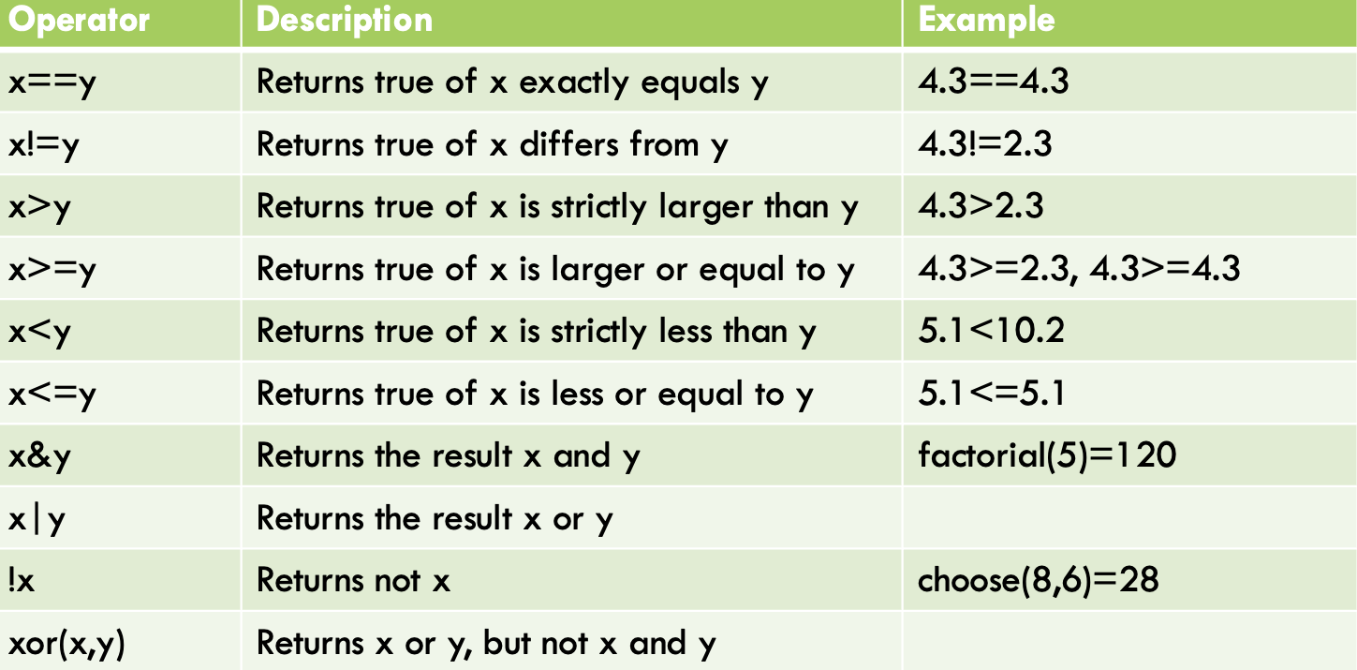
Vector Operators
- 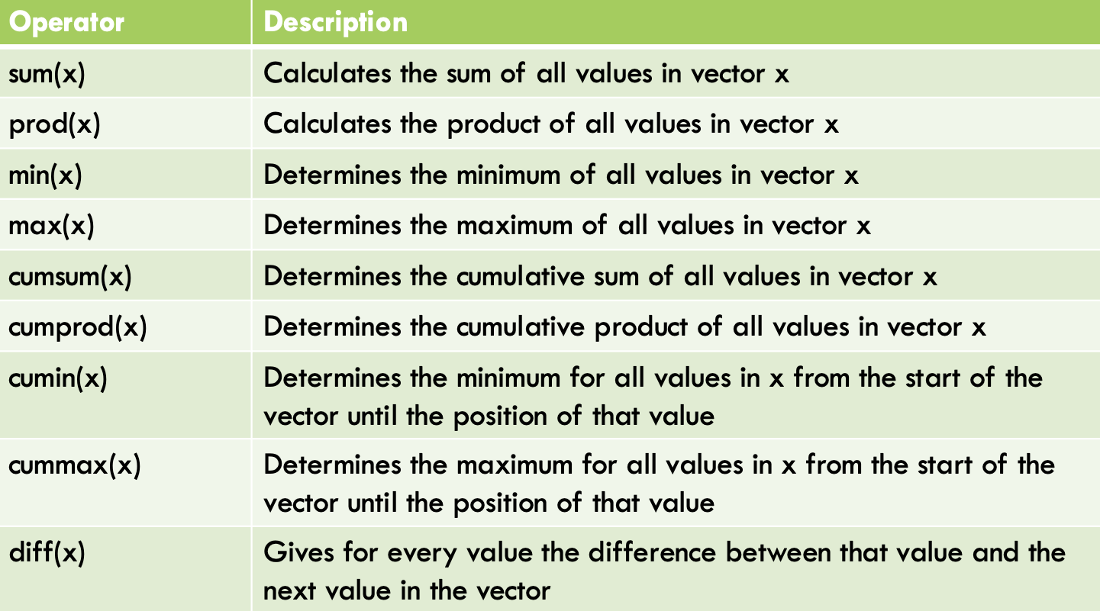
Examples of Vector Operations
- > #Creating a column vector, named x
- > x<-c(1,3,5,7,9)
- > #Calculates the sum of all values in vector x
- > sum(x)
- [1] 25
- > #Calculates the product of all values in vector x
- > prod(x)
- [1] 945
- > #Determines the minimum of all values in vector x
- > min(x)
- [1] 1
- > #Determines the maximum of all values in vector x
- > max(x)
- [1] 9
- > #Determines the cumulative sum of all values in
- > #vector x
- > cumsum(x)
- [1] 1 4 9 16 25
- > #Determines the cumulative product of all values in
- > #vector x
- > cumprod(x)
- [1] 1 3 15 105 945
- > #Determines the minimum for all values in x from the > #start of the vector until the position of that value
- > cummin(x)
- [1] 1 1 1 1 1
- > #Determines the maximum for all values in x from > #the start of the vector until the position of that value
- > cummax(x)
- [1] 1 3 5 7 9
- > #Gives for every value the difference between that value and the next value in the vector
- > diff(x)
- [1] 2 2 2 2
Storing Values – Working with Categorical/Qualitative Values
- R Studio and Categorical Variables. Be careful when you copy and paste code, because R recognizes only specific fonts for “quotes”
- > #code to create categorical/qualitative variable values
- > h<-"Hi There!"
- > h
- [1] "Hi There!"
- > #creating a vector called “cat1”
- > cat1<-c("red","blue", "green")
- > cat1
- [1] "red" "blue" "green“
Scientific Notation and Rounding Numbers
R can understand and represent numbers using scientific notation
- > #Raising a large number to a power will generally make R output answer using Scientific Notation
- > 1002^19
- [1] 1.038692e+57
- > #Inputting the number 1.02X 10^4 as 1.02e4 will generate the following answer
- > 1.02e4
- [1] 10200
R can calculate accurately up to 16 digits. You may want to round to a certain number of digits
- > #Rounding to 2 decimal places
- > round(1.177734, digits = 2)
- [1] 1.18
- >round(1.177734, digits = 0)
- [1] 1
- > #Round to multiples of 10, put in negative numbers for digit =, -1 to the tens, -2 to the hundreds, etc.
- > round (1643, digits = -3)
- [1] 2000
- > round (1643, digits = -2)
- [1] 1600
- > round (1643, digits = -1)
- [1] 1640
- > round (1643.5, digits = -0)
- [1] 1644
R can calculate and give answers to designated significant digits
- > #Answer having 4 significant digits
- > signif(1.177734, digits = 4)
- [1] 1.178
Storing Values – Working with Categorical/Qualitative Values
Putting an argument in a function
- > #print function to print out a Life is Good
- >print (x = “Life is Good”)
- [1] "Life is Good"
- >#alternate way
- > y = "Life is Good"
- > print(y)
- [1] "Life is Good"
- >#Code to print out the value of x = 13/7 to 3 decimal places
- >print(digits=4, x=13/7)
- [1] 1.857
Vectorized functions – works not just on a single value, but on a whole vector of values at the same time
- > #code to create categorical/qualitative variable values of people’s first names
- >first_name <- c ("Tom", "Jing", "Jorge", "Versal")
- > #code to create categorical/qualitative variable values of people’s last names
- > last_name <- c ("Jones", "Chen", "Mayes", "Debrei")
- >#Code to put first and last names together
- > paste(first_name,last_name)
- [1] "Tom Jones" "Jing Chen" "Jorge Mayes" "Versal Debrei"
Vectorized functions con.
- > #code to create categorical/qualitative variable values of people’s first names
- >first_name <- c ("John", "Mike", "Joe", "Theresa", "Sophia")
- >#code to create categorical/qualitative variable values of siblings' last names
- >last_name <- "Shepard"
- >#Code to put first names of siblings and last name together
- >paste(first_name,last_name)
- [1] "John Shepard" "Mike Shepard" "Joe Shepard" "Theresa Shepard" "Sophia Shepard"
Working with Vectors – lapply
lapply (applying a function to corresponding elements of a vector)
- > #code to create data set
- >data_set<-c(9,11,13,15,16,19,21,23,25,27,29,36)
- >#code to take the square root of all elements in data_set
- >lapply(data_set, sqrt)
- RESULTS:
- [[1]]
- [1] 3
- [[2]]
- [1] 3.316625
- [[3]]
- [1] 3.605551
- [[4]]
- [1] 3.872983
- [[5]]
- [1] 4
- [[6]]
- [1] 4.358899
- [[7]]
- [1] 4.582576
- [[8]]
- [1] 4.795832
- [[9]]
- [1] 5
- [[10]]
- [1] 5.196152
- [[11]]
- [1] 5.385165
- [[12]]
- [1] 6
lapply (applying a function to multiple arguments)
- > #code to create data set
- >a<-list(A=c(16,24,33,20,19,30,19), B=c(95,88,87,92,90))
- >#code to get the 5 number summary: min 1st quartile, 2nd quartile, and 3rd quartile max
- >lapply(a,quantile)
- RESULTS:
- $A
- 0% 25% 50% 75% 100%
- 16 19 20 27 33
- $B
- 0% 25% 50% 75% 100%
- 87 88 90 92 95
Replicate (repeatedly evaluate some expression)
- > #replicate the value “Happy” 3 times
- >> replicate(n=3,"Happy")
- [1] "Happy" "Happy" "Happy"
Working with Vectors –replicate
Replicate (We can use the replicate() function to produce 5 different samples and we can then use the colMeans() function to find the mean value of each sample:)
- > #make this example reproducible
- > set.seed(1)
- > #create 10 samples each of size n=5
- > data <- replicate(n=5, rnorm(10, mean=0, sd=1))
- > #view samples
- > data
- [,1] [,2] [,3] [,4] [,5]
- [1,] -0.6264538 1.51178117 0.91897737 1.35867955 -0.1645236
- [2,] 0.1836433 0.38984324 0.78213630 -0.10278773 -0.2533617
- [3,] -0.8356286 -0.62124058 0.07456498 0.38767161 0.6969634
- [4,] 1.5952808 -2.21469989 -1.98935170 -0.05380504 0.5566632
- [5,] 0.3295078 1.12493092 0.61982575 -1.37705956 -0.6887557
- [6,] -0.8204684 -0.04493361 -0.05612874 -0.41499456 -0.7074952
- [7,] 0.4874291 -0.01619026 -0.15579551 -0.39428995 0.3645820
- [8,] 0.7383247 0.94383621 -1.47075238 -0.05931340 0.7685329
- [9,] 0.5757814 0.82122120 -0.47815006 1.10002537 -0.1123462
- [10,] -0.3053884 0.59390132 0.41794156 0.76317575 0.8811077
- > #calculate mean of each sample
- > colMeans(data)
- [1] 0.1322028 0.2488450 -0.1336732 0.1207302 0.1341367
- You can end an incomplete code with an operator (like +, /, <-, and so on), R will know that something else must follow. This allows you to crate structure in longer calculations
- > #code to create a function that will add three numbers
- >sum.vals = function(x,y,z)
- + {
- + sum = x + y + z
- + print(digits=2,sum)
- + }
- > sum.vals(1.2,1.3,1.4)
- [1] 3.9

